Pre – Requisite: Ensure that Emp and Dept tables are created as below and it contains records.

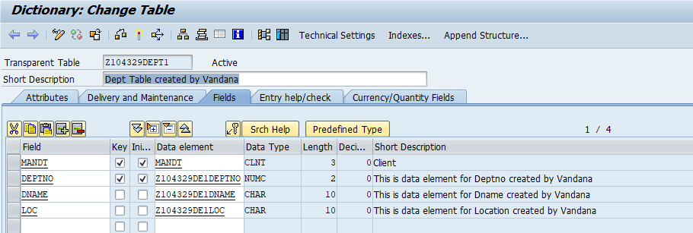

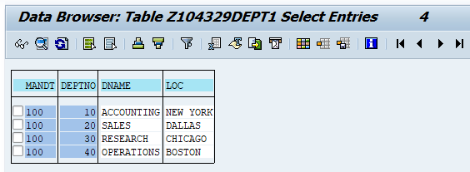

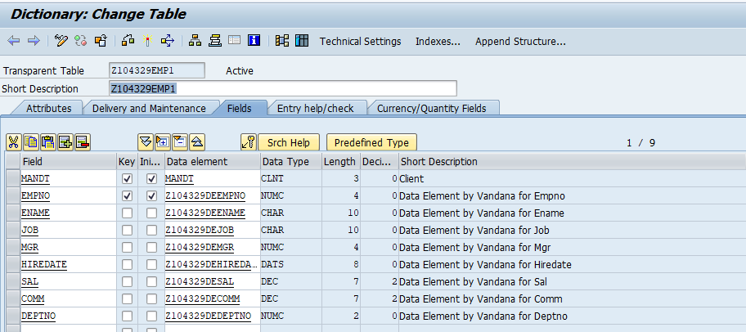

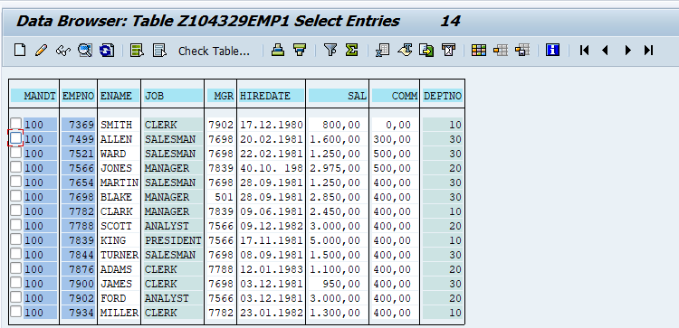

There may be a relationship between Emp and Dept tables.

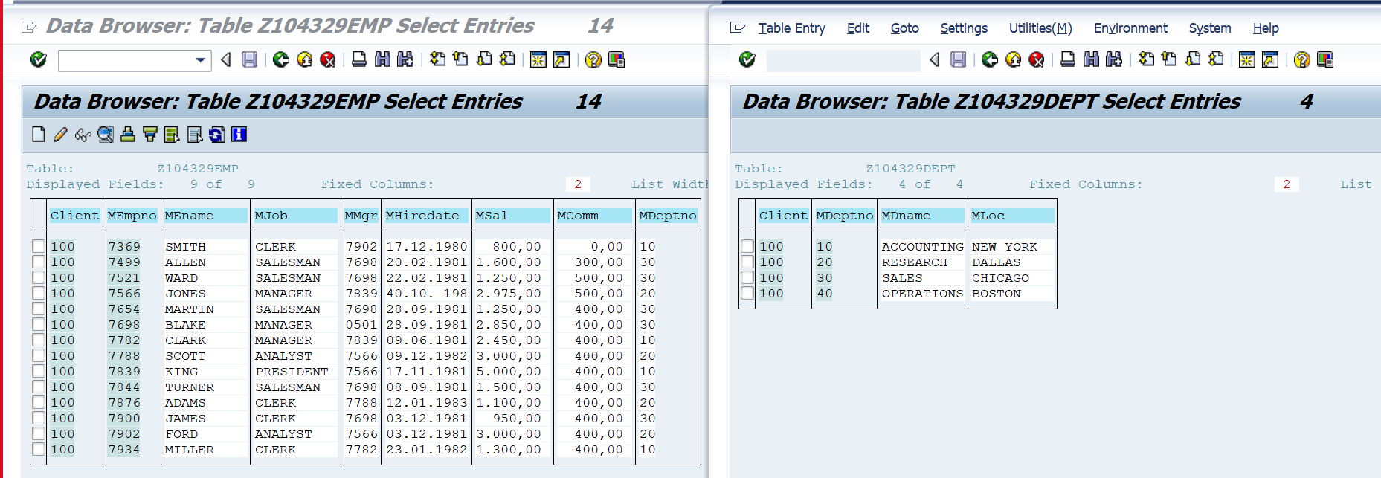

Note : This is optional.

Scenario 1: No Relation Ship Between Emp and Dept table.

1. Go to SE11
2. Create a DB View. Click on Relationships.

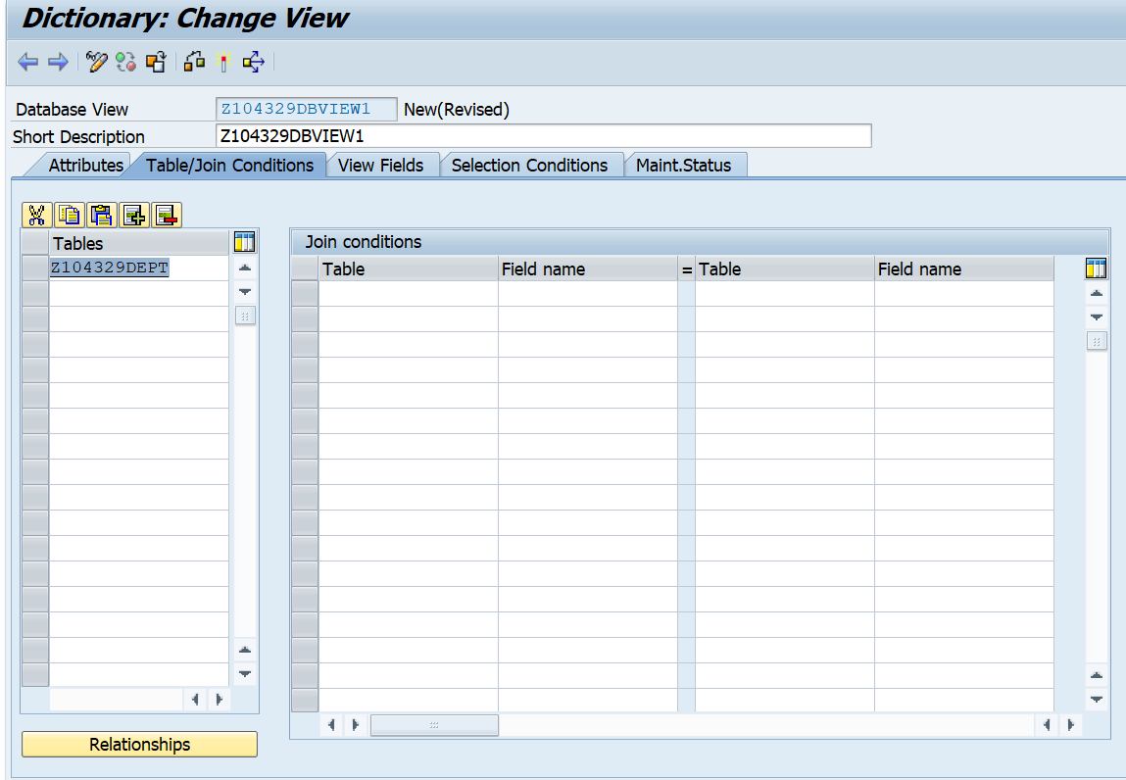

1. You will see message as below in the status bar.

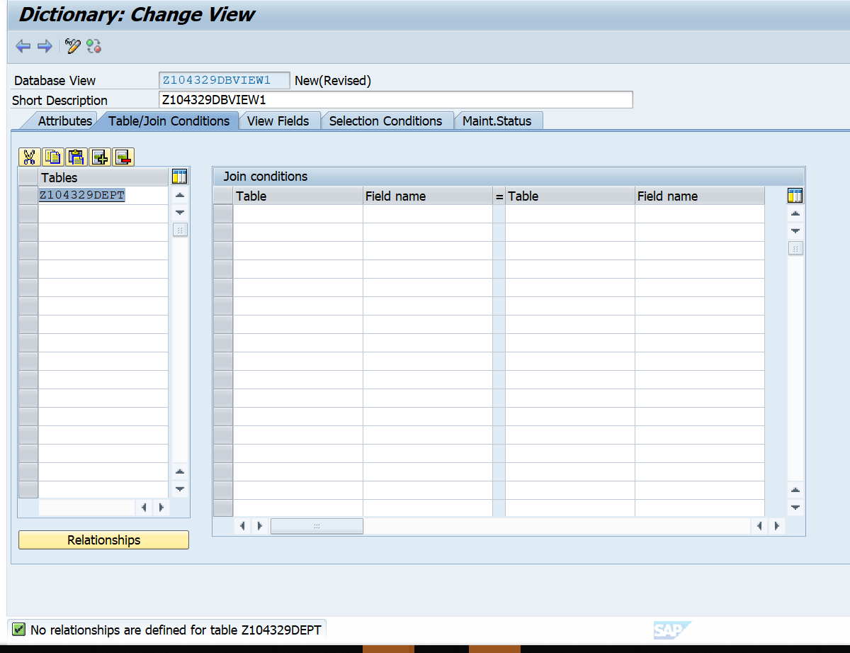

1. In the tables enter Z104329EMP. Type the join conditions as shown below.

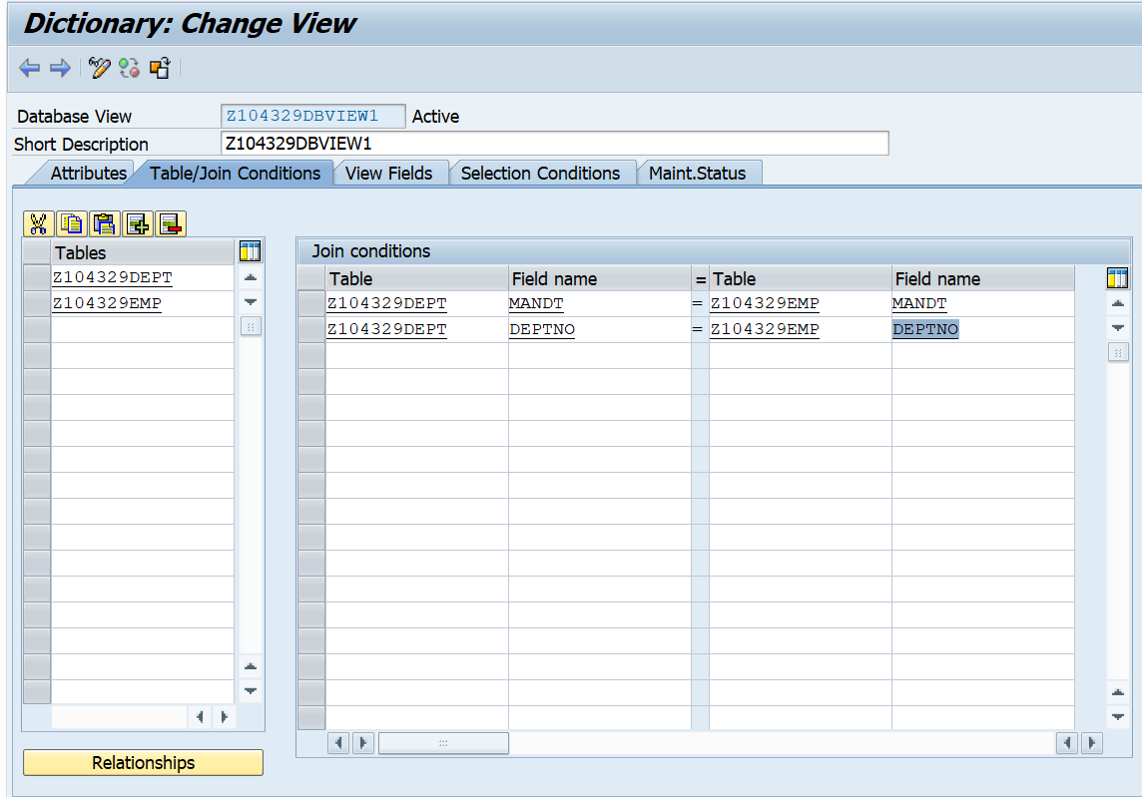

1. In the view fields tab, select the fields from each of the tables.

Deptno field is present in both tables. In the view, we are selecting deptno from both table. The fieldnames cannot be deptno in the view, else it will result in ambiguity.

Hence, to distinguish the field is prefixed with the name of the table. E.g Emp_Deptno and Dept_Deptno.

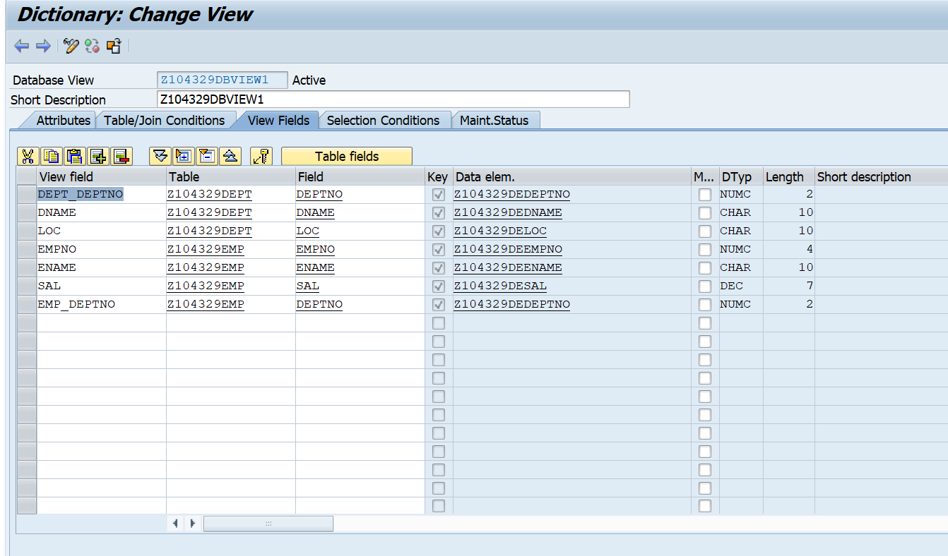

1. Activate the view. See the output.

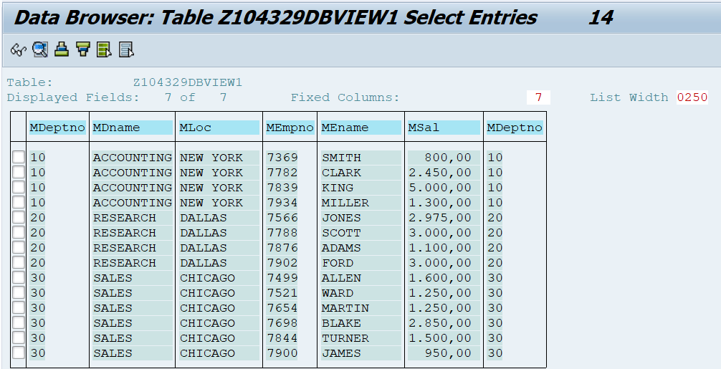

**Scenario 2: There is Relation Ship Between Emp and Dept table as shown below.**

1. Ensure that there is a Relationship Between Emp and Dept table as shown below

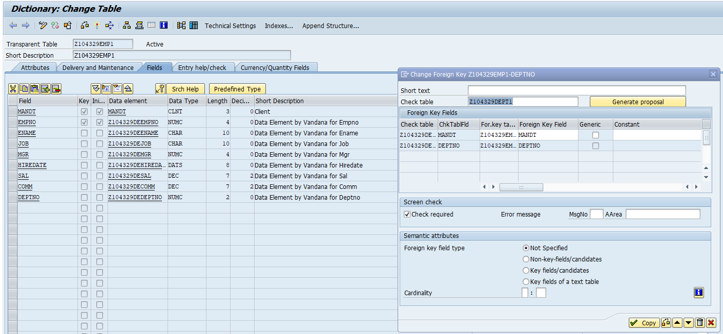

2. Create Dictionary view based on 2 tables.

3. Enter the table names as shown below.

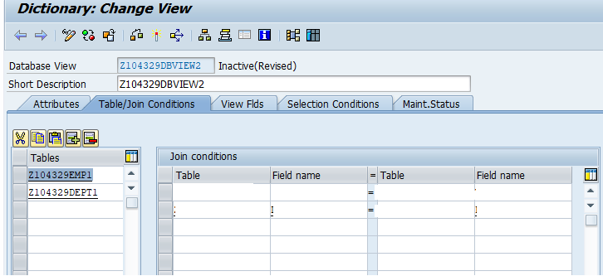

4. To create a relationship, click on any one table E.g Z104329Emp1 and then click on relationships.

5. Select the check box.

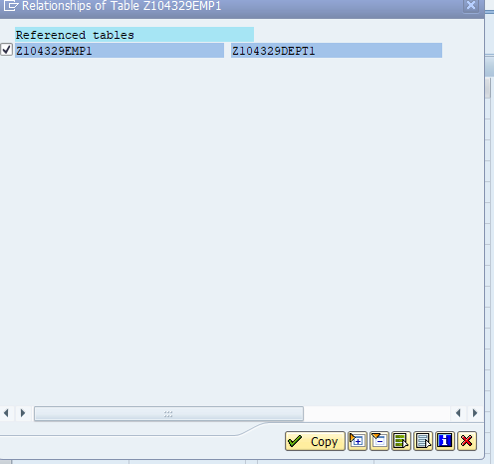

1. The relationship will be created as shown in screen below.

: 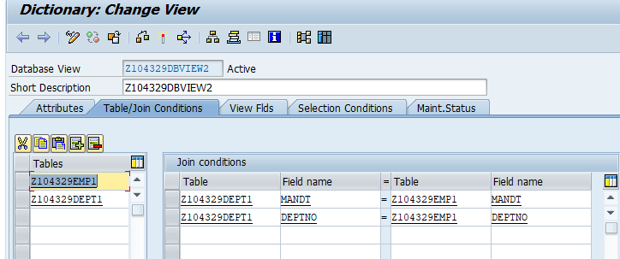

***Note: If there is NO relationship between tables, the join conditions can be manually entered.***

1. Click on View Flds tab. Click on Table Fields. Choose Emp1 table as shown below.

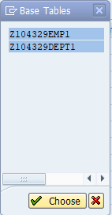

Select Fields as shown below and click on copy.

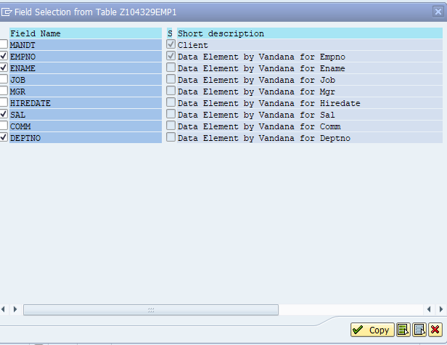

Similarly select fields from Dept table. Deptno field is present in both tables. In the view, we are selecting deptno from both table. The fieldnames cannot be deptno in the view, else it will result in ambiguity.

Hence, to distinguish the field is prefixed with the name of the table. E.g Emp_Deptno and Dept_Deptno.

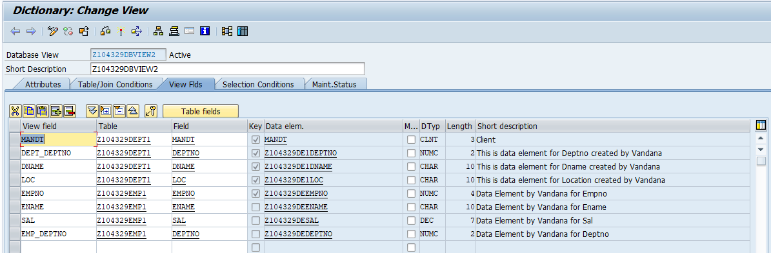

Specifying selection condition is optional.

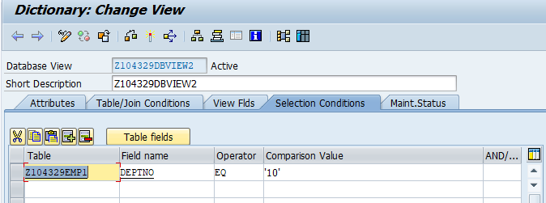

View the records.

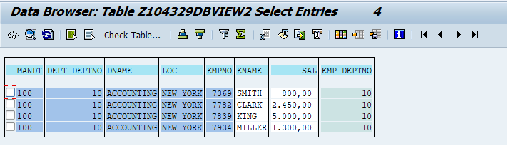

Observe that in the DataBase view the maintenance status cannot be changed.

